Instructions for a parent to be able to move their child into the next swimming level

The Parent/Guardian will need to then log in to their Homeportal account and see the child with a Move option under their name, they have to click this.
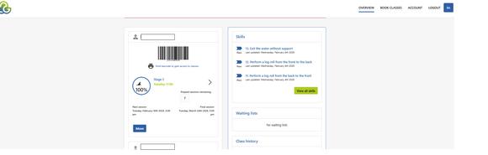
Then then click the Green button on the right to 'Choose Class'
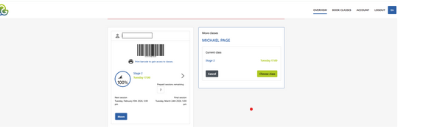

You will then receive the options for the next level which has available spaces for them to choose the class which suits them and click in to this.

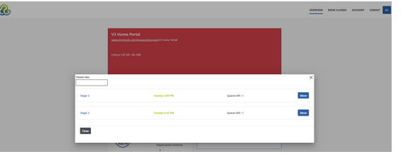

You will be asked to confirm this class you have chosen.
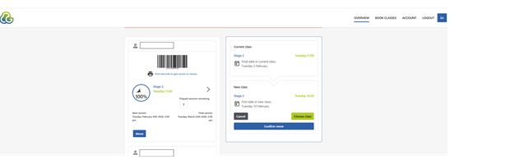

This has then moved the child to the new class/level and will show the new class as below for you.

